Homework 4 – Michael Ng

3.38
<ClockDisplay Class, New Constructors>
/**
* Constructor for objects of class NumberDisplay.
* Set the limit at which the display rolls over.
* The hours limit has been altered to 13 hours in this case.
*/
public ClockDisplay(int hour, int minute)
{
// setting the limit to 13 allows it to be 00:00 – 12:59.
hours = new NumberDisplay(13);
minutes = new NumberDisplay(60);
setTime(hour, minute);
}
/**
* Default Constructor for ClockDisplay objects.
*/
public ClockDisplay()
{
hours = new NumberDisplay(13);
minutes = new NumberDisplay(60);
updateDisplay();
}
/**
* This method should get called once every minute - it makes
* the clock display go one minute forward.
* If the hours has recently rolledover, increments hour.
*/
<ClockDisplay Class, new timeTick method>
public void timeTick()
{
minutes.increment();
if(minutes.getValue() == 0) { // it just rolled over!
hours.increment();

//Happens directly after incrementing hours. If Hours is equal to zero, it is incremented to 1, so the time is //“1:00” instead of “0:00”.
if(hours.getValue() == 0)
{
hours.increment();
updateDisplay();
}
}
updateDisplay();
}

3.40-

3.41
/**
* Creates a tree in the Canvas of the figures Project.
*
* @author Michael Ng - ngmw01@etsu.edu
* @Version 9/17/2020
*/
public class Tree
{
// instance variables - replace the example below with your own
private Triangle leaves;
private Square trunk;

/**
* Constructor for objects of class Tree.
* Defines the 'trunk' and 'leaves' fields and moves the trunk Square beneath the leaves Triangle,
* and alters the size of the leaves Triangle.
*/
public Tree()
{
leaves = new Triangle();
trunk = new Square();
trunk.moveHorizontal(-120);
trunk.moveVertical(75);
leaves.moveVertical(-40);
trunk.changeSize(40);
leaves.changeSize(100, 70);
}

/**
* The setup method changes the color of the leaves Triangle and
* trunk Square, and makes both of them visible.
*/
public void setup()
{
leaves.makeVisible();
trunk.makeVisible();
trunk.changeColor("black");
leaves.changeColor("green");
}
}

3.51
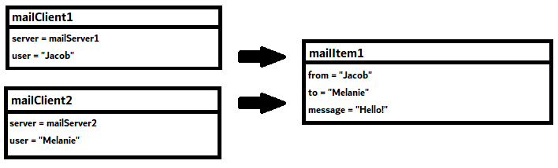
The when the mailClient object is contructed, it defines the user with a String. The mailItem object interacts with the mailClient object by defining its from and to Strings based on the mailClient’s user fields.

3.59
It is possible, if there are variables in the NumberDisplay class that can keep track of the time in ClockDisplay, or the timetick method updates NumberDisplay objects.
timeTick would interact with the minutes NumberDisplay object the most, since it can increment the hours when it rolls over.
NumberDisplay would have a new hrs and mins field of type integer.
When a whole day has elapsed, the hours object should rollback to 0. If there is an integer that keeps track of days passed, it would be incremented by 1.

<NumberDisplay Class>
public class NumberDisplay
{
private int limit;
private int value;
//Added hrs and mins fields to keep track of hours and minutes in clockDisplay.
private int hrs;
private int mins;
/**
* Constructor for objects of class NumberDisplay.
* Set the limit at which the display rolls over.
*/
public NumberDisplay(int rollOverLimit)
{
limit = rollOverLimit;
value = 0;
if(limit == 24)
{
hrs = value;
}
if(limit == 60)
{
mins = value;
}
}

/**
* Return the current value.
*/
public int getValue()
{
return value;
}

/**
* Return the display value (that is, the current value as a two-digit
* String. If the value is less than ten, it will be padded with a leading
* zero).
*/
public String getDisplayValue()
{
if(value < 10) {
return "0" + value;
}
else {
return "" + value;
}
}

/**
* Set the value of the display to the new specified value. If the new
* value is less than zero or over the limit, do nothing.
*/
public void setValue(int replacementValue)
{
if((replacementValue >= 0) && (replacementValue < limit)) {
value = replacementValue;
}
}
/**
* Increment the display value by one, rolling over to zero if the
* limit is reached. If minute rollsover, hours is incremented.
*/
public void increment()
{
value = (value + 1);
if((value % limit) == 0 && limit == 60)
{
value = value % limit;
hrs = hrs + 1;
}
}
}

